

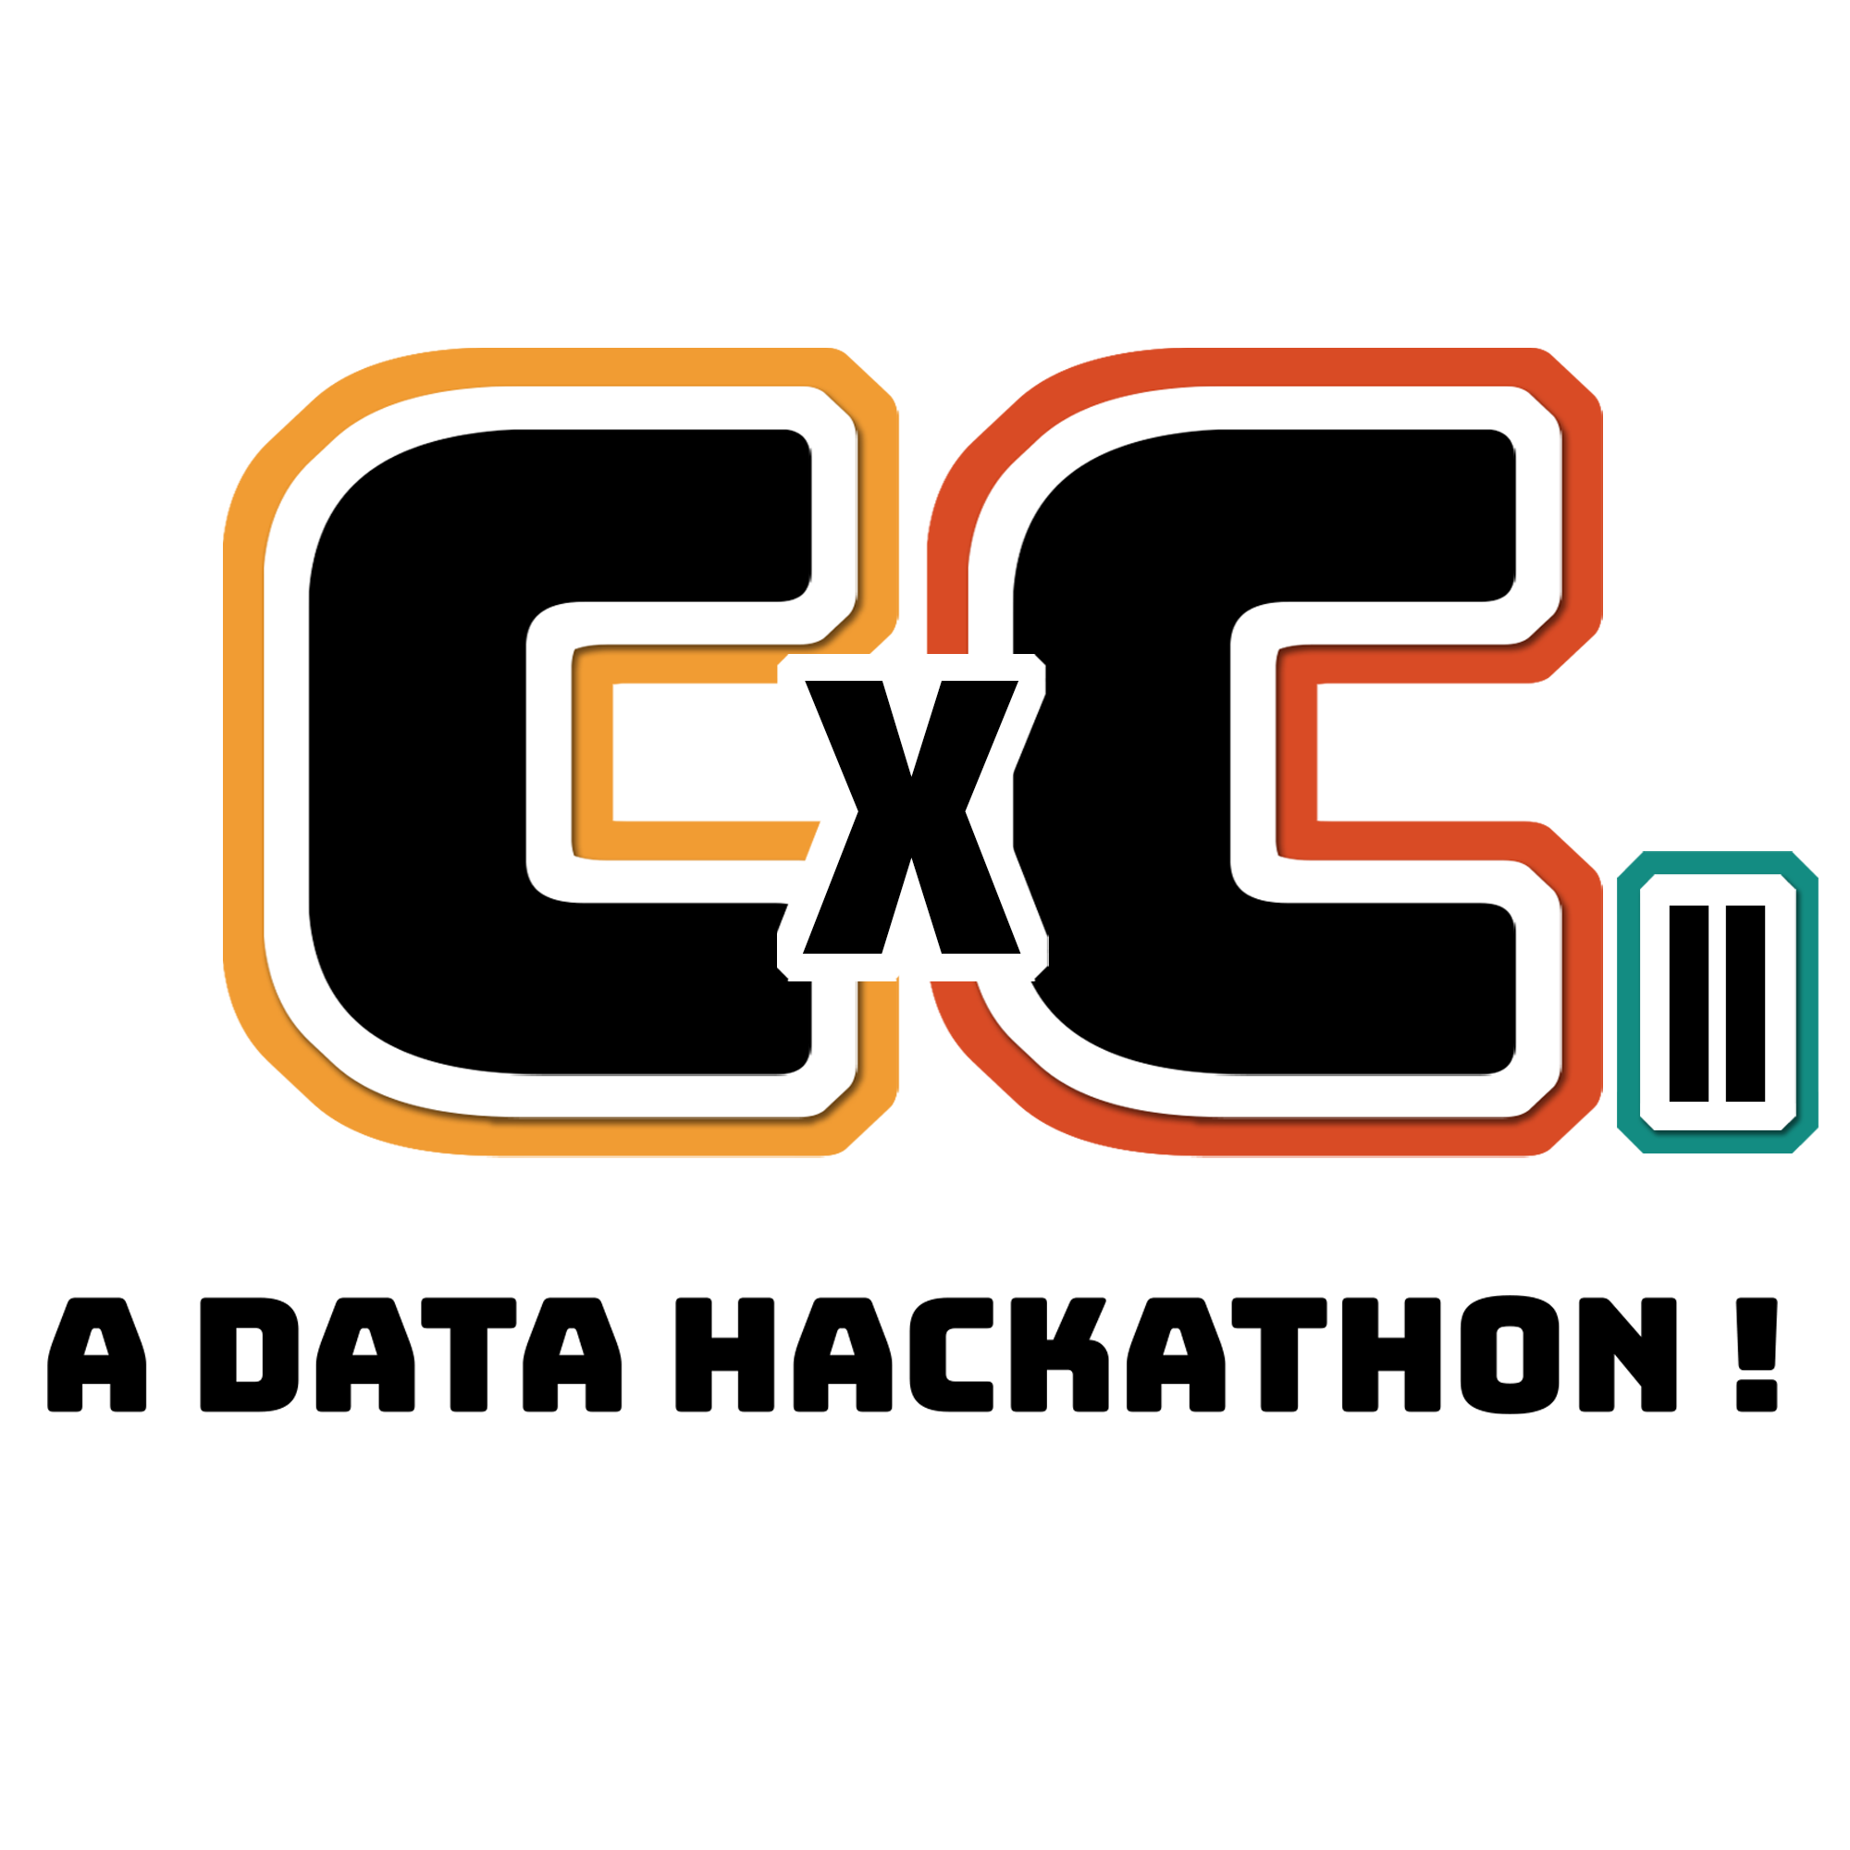

CxC Participant Event Guide

Table of Contents

Introduction **3**

Rules & How It Works **3**

Platforms **4**

Schedule Overview **4**

Events Schedule **4**

Event/Activity Descriptions **5**

Floorplan **6**

Checklist **8**

Sponsors **8**

FAQs **9**

Important Links

Discord: <https://discord.com/invite/VP36xnXYdB>

Hopin: <https://hopin.com/events/uw-data-science-club>

Devpost: <https://cxc.devpost.com/>

# Introduction

Attention all University of Waterloo students! CxC is back so get ready for Waterloo’s premier data science hackathon organized by UWaterloo Data Science Club. Join us for an exciting two weeks full of fun data analysis, and problem-solving as we push the limits of what's possible in data science.

Whether you’re a seasoned data scientist or just someone interested in the field, CxC is the perfect place for you to explore and showcase your skills. Work with a team of like-minded individuals and dive into real-world data problems, using the latest tools and technologies to come up with innovative solutions.

You will also have the opportunity to network with top industry professionals, gain valuable insights into the world of data science, and receive feedback on your work from some of the best in the business. And, of course, there are amazing prizes up for grabs with **over $5,000** in resources and prize pool!

CxC will take place from February 10 to February 24 where you will have the option to attend the Friday and Saturday sessions in person to join us for the opening ceremony, socials, workshops, lunch, dinner, and snacks at MC or virtually through Hopin. See the event schedule below for more details.

# Rules & How It Works

There are three datasets provided by Intact, Cyclica and Wyvern. Your goal is to train and fit models that best predict the required labels. For your submissions to be considered, please do all of the following.

1. Upload your final project to Devpost, **with a GitHub** **link** to your project repository, and a ~2 minute video outlining your project, including technologies used, challenges faced, and of course the overall outcomes.
   1. The Github repository must contain enough code and instructions to be reproducible. Models will be re-run and evaluated for the top submissions.
2. Submit the Google Form that compiles the links of the previous points, as well as your team members and contact information
   1. In the Google Form, you are required to submit a csv file of the computed labels

Each dataset has a different metric that we will be evaluating on, more details will be shared once the datasets are released. You may pick more than one dataset/ challenge to work on.

In order **to be eligible** for prizes, you must be a Data Science Club member and have paid your membership fees at least two days prior to the deadline.

# Platforms

We will be using Hopin as our hybrid/virtual events platform, Discord for announcements, team-finding, mentorship, and messaging, Eventbrite for sign-ups and check-ins, and Devpost for project submissions. Also please feel free to use GitHub and other technology platforms as needed by you and your team.

# Schedule Overview

We have a variety of events planned for both in-person and online attendees, below is a brief overview of what you can expect at each event. Please be sure to check the event schedule for more details!

**Day 1**:

Opening Ceremony: Join us as we introduce CxC and give a timeline overview of what to expect over the next two weeks with us. We will also have company introductions/spotlights during this time and an introduction into the details of the data challenge.

Dinner/Social: This time will be dedicated to CxC provided dinner, socializing and team-forming.

Workshops & Activities: The rest of Day 1 will be dedicated to a variety of in-person workshops and fun activities like the fire noodles challenge.

**Day 2**:

Will be more dedicated towards more workshops and activities throughout the day, followed by a lunch/social, Virtual Kaggle Panel with GM Mikel Bober-Irizar and GM Ruchi Bhatia, and virtual company booths.

# Events Schedule

FRIDAY

| 5:30 pm | **Check-ins** MC 1085   * Have Eventbrite QR Codes on hand | | |
| --- | --- | --- | --- |
| **Opening Ceremonies (6 - 7:30)** MC 1085 | | | |
| 6:00 pm | **Welcome** - Intro to hackathon + events timeline overview | | |
| 6:30 pm | **Company Intros** (in-person) - company spotlights, introductions, hackathon contributions, etc.  **Dataset + Challenge** intros | | |
| **Social/Dinner (7:30 - 9)** Drinks and snacks provided too | | | |
| 7:30 pm | **Team-finding** MC 4045 | **Dinner** - MC 4059 | **Activities**  **Board games** MC 4058  **Tote bag painting**  MC 4060 |
| 8:00 pm | **Hacking time** MC 4045 |
| 10:00 pm | **Activities**  **Fire Noodles** - MC 4059 | |

SATURDAY

| **Workshop/Activities Day** MC 2nd Floor | |
| --- | --- |
| 10:00 am | Data Analysis (Numpy and Pandas) Workshop - MC 2034 |
| 11:00 am | Chat Bots + NLP Workshop - MC 2035 |
| **Lunch (12 - 1) MC 2017**  Drinks and snacks provided too | |
| 1:00 pm | Computer Vision + Gradio Workshop - MC 2034 |
| 2:00 pm | SQL Workshop + Q&A - MC 2035 |
| 3:00 pm | Intro to Machine Learning Workshop - MC 2034 |
| 6:30 pm | Virtual Kaggle Panel with GM Mikel Bober-Irizar and GM Ruchi Bhatia |
| 7:30 pm | Virtual company booths, ft.   * AltaML * BDO * Wyvern |

Thursday Feb 23rd: submissions due on <https://forms.gle/eHVmMXUECVSZ4W748>

Friday Feb 24th: **virtual** closing ceremonies in the evening

# Event/Activity Descriptions

**Fire Noodles**: Put your taste buds to the test and see if you have what it takes to conquer the fire noodles challenge :P

**Board Games**: Take a break from coding and join us for an evening of board games. Bring your strategy skills and compete with fellow participants for bragging rights.

**Tote Bag Painting**: Get creative and join us for a tote bag painting event where you could design your own unique tote bag and take home a one-of-a-kind accessory.

**Data Analysis (Numpy and Pandas) Workshop**: Get started with Data Science in Python with Jupyter Notebooks and the Titanic Kaggle challenge.

**Computer Vision + Gradio Workshop**: Learn the basics of Computer Vision and Gradio, the fastest way to demo your machine learning model, to take your ML skills to the next level!

**SQL Workshop:** WiCS is hosting an Introduction to SQL workshop! In the first half, individuals will learn about SQL and write basic queries in order to solve a murder mystery puzzle. The second half will be a Q&A with WiCS about anything, from club involvement to co-op recruiting and more.

**Virtual Kaggle Panel**: Gain valuable insights into the world of Kaggle and learn how to up your data science game with GM Mikel Bober-Irizar and GM Ruchi Bhatia.

**Virtual company booths**: Explore the latest trends and technologies and connect with industry leaders.

# Floorplan

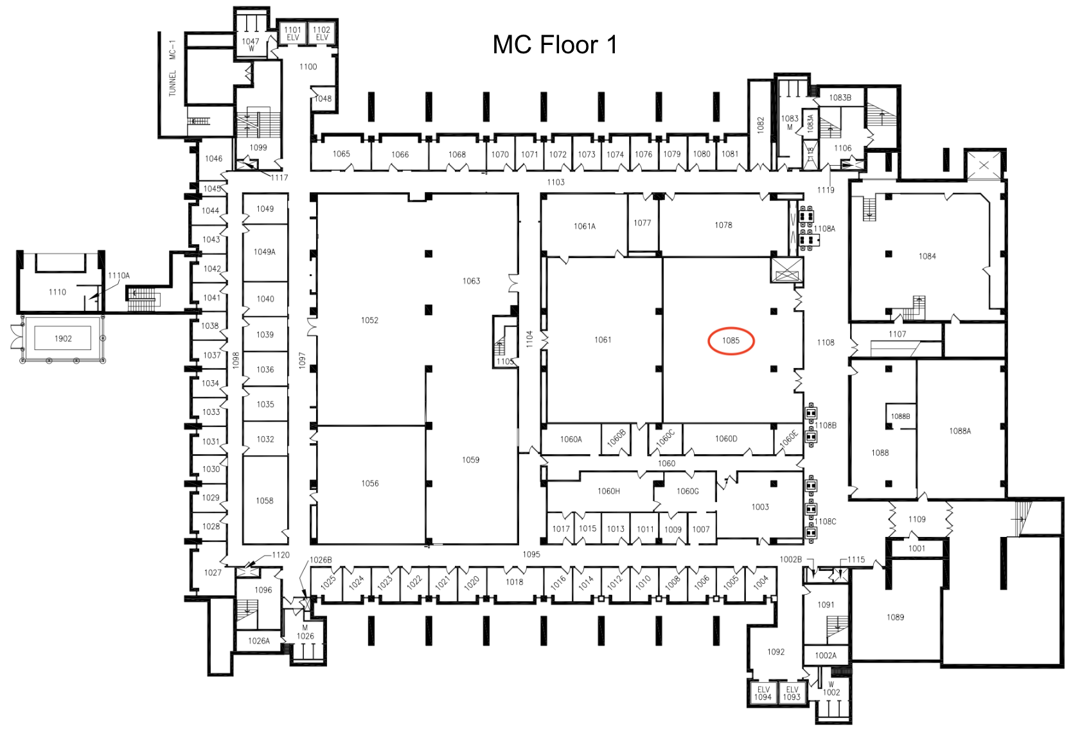

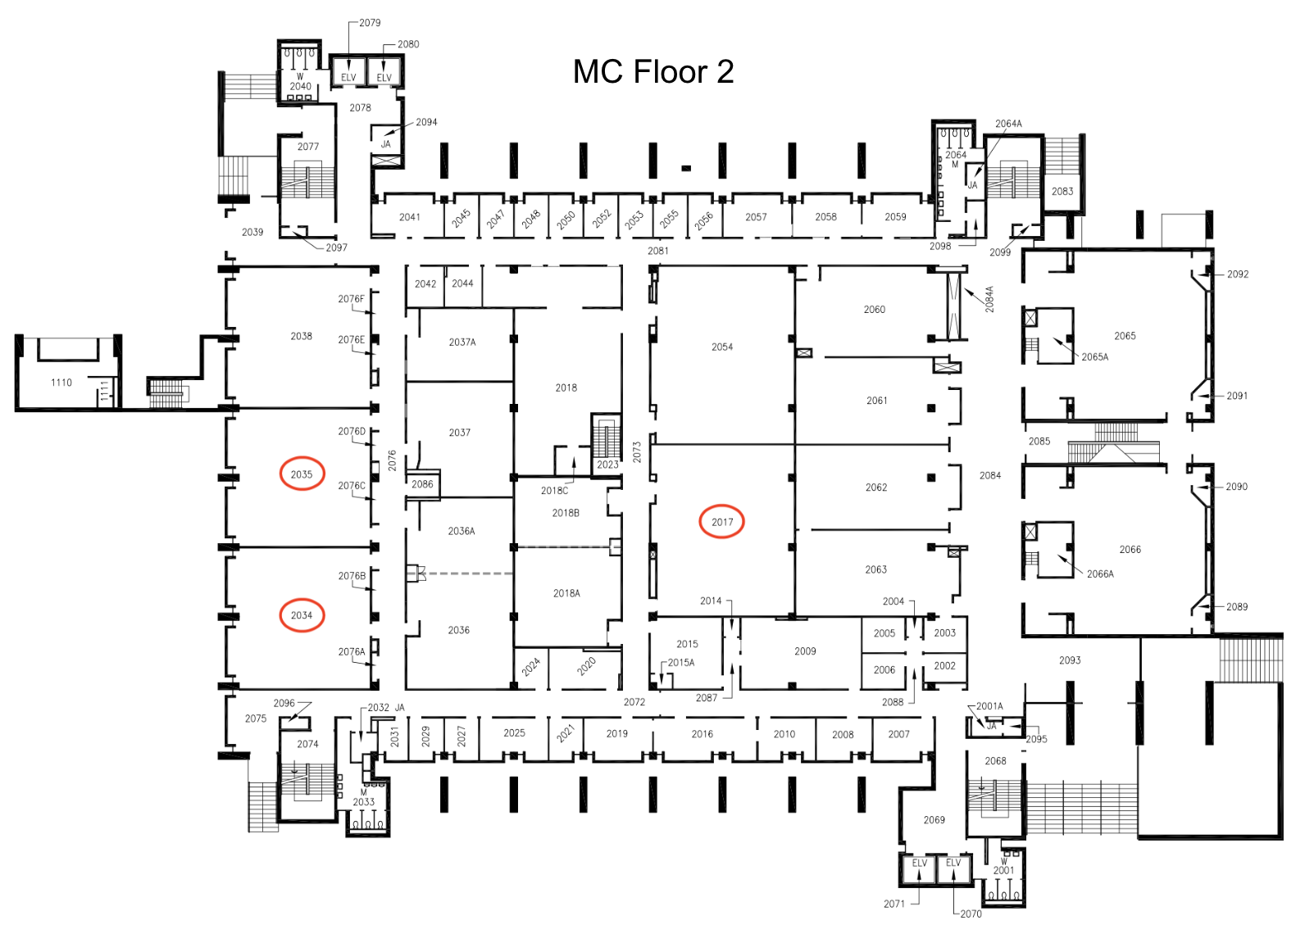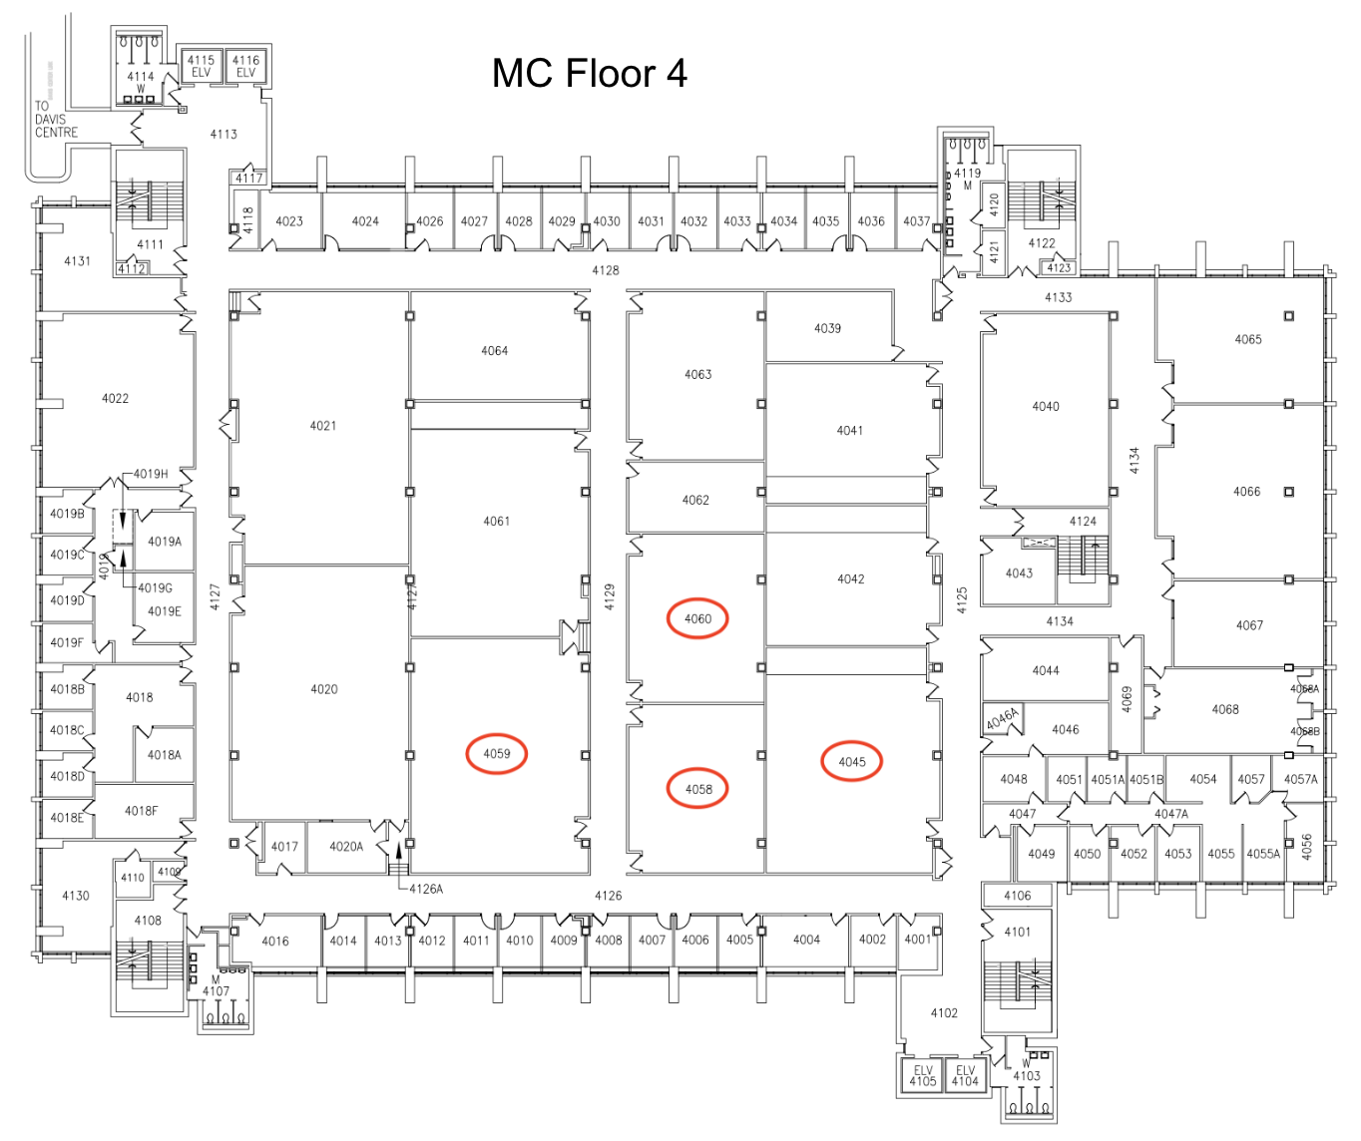

# Checklist

To make sure you’re best prepared for the event please be sure to bring:

* Device/tech to work with
* Chargers
* Headphones
* Notebook/pens if you’d like to take any notes

For in-person

* QR codes from Eventbrite tickets
* Cash if you are paying the membership fee

# Sponsors

Special thanks to all of our sponsors:

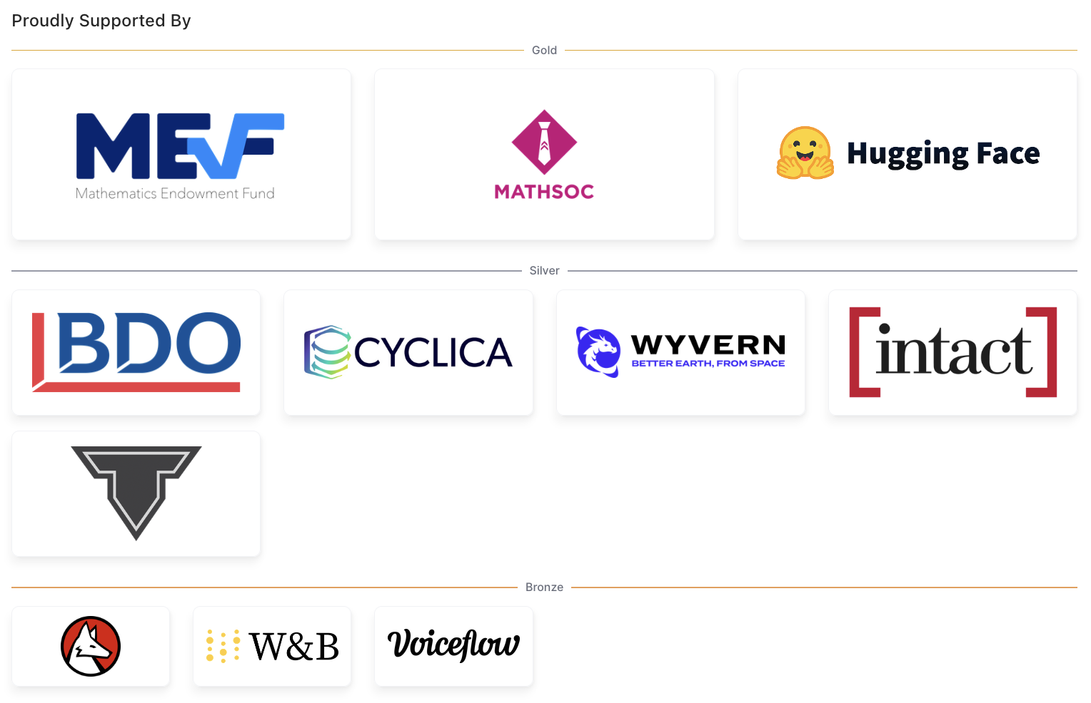

# 

# FAQs

Q: What’s a data hackathon?

A: It’s an event where people can work in teams to tackle data-related challenges, such as making predictions or classifications from the given data sets. At CxC, we are also hosting some social activities, introductory workshops, a Kaggle panel, company booths, and more to help you connect with other participants, industry experts, and learn more data science.

Q: My partners are online while I am in-person, is that okay?

A: Yep! The only in-person portions are for dinner, workshops and opening ceremony. Final submissions are all online.

Q: What if I have zero experience in data science?

A: We are hosting beginner friendly workshops to help you learn some useful skills for the challenges. We will also be providing asynchronous mentorship support on the CxC Discord.

Q: Why is it 2 weeks?

A: We want to provide participants with more time to finish and make a submission. Our timeline goes through reading week, so you would have some time to work while studying for midterms.

Q: Do I need a team of 4? How can I find one?

A: Not at all. A team can include up to 4 people, and we do recommend you to join one to have more support and ideas when working with the data. You also would not be winning more prize money working alone than winning as a team.

We have a channel on Discord dedicated to introductions, which can help you connect with others who are looking for a team. You will also have time to find one during the Friday opening ceremonies night.

Q: Who’s judging?

A: Company representatives from the dataset sponsors as well as executives from DSC’s Education team.

Q: Do I need to be…

a UW student to participate? Yes

a DSC/CSC/WICS member to participate? No. However, you would need to become a DSC member to win prizes and attend in-person activities. To become a member, fill out the membership form on our linktree in bio and visit us during office hours or any of our events to pay the membership fee. You must have paid the membership fee at least two days prior to the project submission deadline.

Q: What are the in-person components of this hackathon?

A: If you signed up for in-person tickets, amazing! You will get to meet people, get food and go to workshops/activities on the first two days of the event. You can also participate in the event virtually without going to any of the in-person sessions. Most workshops will be streamed and recorded online as well.